**CAR RESALE VALUE**

1. **INTRODUCTION**

**1.1 Overview:**

In this project we have used “Random Forest algorithm” to predict the selling price of the used car. The dataset is taken from the Kaggle which is from “Car Dekho” website.

Link of Dataset: [Vehicle dataset | Kaggle](https://www.kaggle.com/datasets/nehalbirla/vehicle-dataset-from-cardekho)

**1.2 Purpose:**

Since there will be no standard selling price for any used vehicle, the price will be set by the owner of the car, this project helps for a buyer to tally the price which was set by the car owner whether it is a fair price deal or not.

1. **LITERATURE SURVEY**

**2.1 Existing problem:**

The problem addressed in this project is the challenge of accurately predicting the resale price of used cars.

Determining the optimal price can be subjective, and numerous factors influence the value of a car, making it a complex task for manual estimation.

**2.2 Proposed solution:**

Existing Approaches or Methods Previous studies and research have explored different approaches to solve the car resale price prediction problem.

These include regression-based models, neural networks, decision trees, and ensemble methods. Random Forest, a popular ensemble learning algorithm, has shown promising results in similar prediction tasks.

1. **THEORITICAL ANALYSIS**

**3.1 Block diagram**

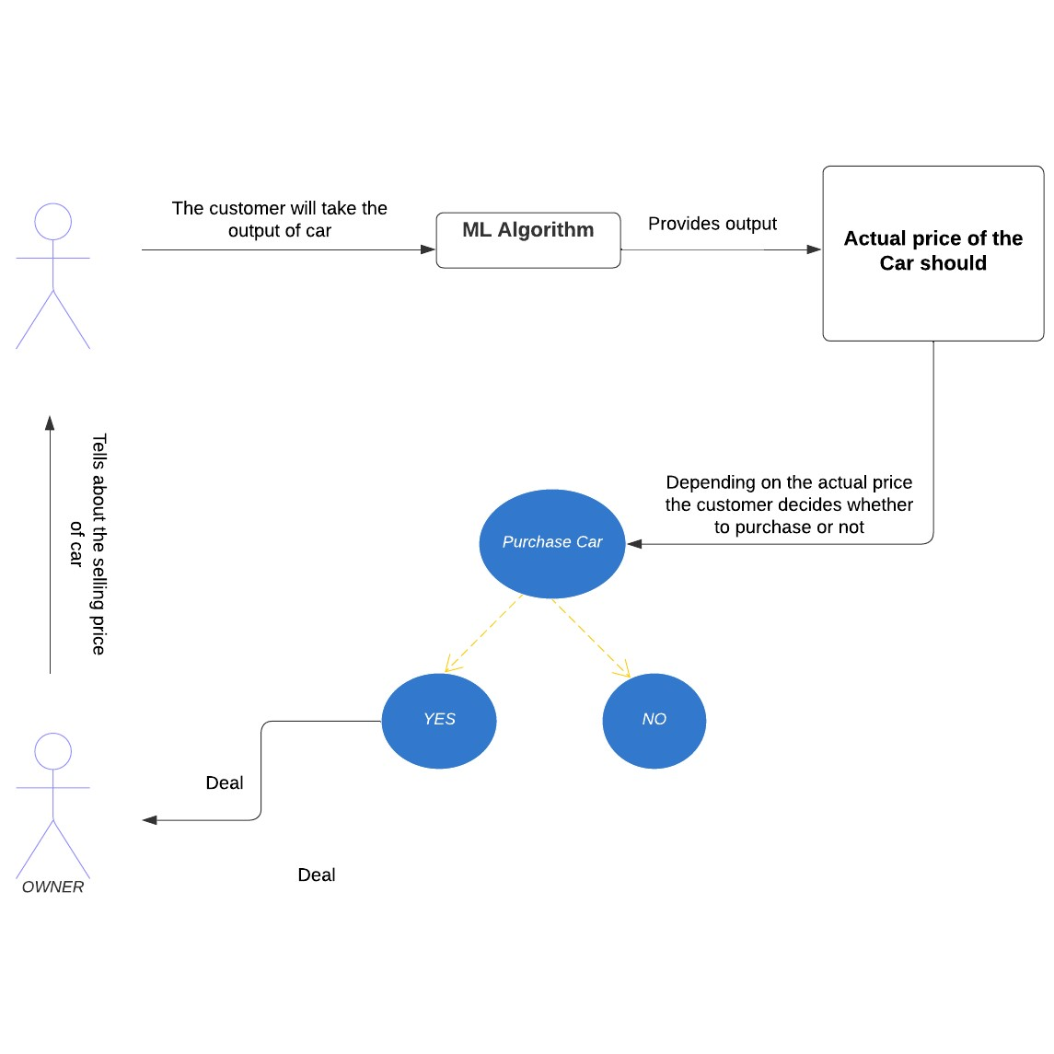

**3.2 Hardware/Software designing:**

Standard computer system with sufficient computational capabilities

Software:

• Programming language (e.g., Python)

• Machine learning libraries (e.g., scikit-learn)

• Data processing and analysis tools (e.g., pandas, NumPy)

• Integrated Development Environment (IDE) (e.g., Jupyter Notebook, PyCharm)

1. **Experimental Investigations**

During the project, various investigations were conducted to develop and evaluate the car resale price prediction model.

These include:

• Data collection and preprocessing: Gathering a dataset of used cars, cleaning the data, and preparing it for analysis.

• Feature selection and engineering: Identifying relevant features and transforming the data to improve prediction accuracy.

**• Implementing Hyper Parameter Tuning.**

• Model training and evaluation: Implementing the Random Forest algorithm, training the model on the prepared data, and evaluating its performance using appropriate metrics (e.g., mean absolute error, root mean squared error).

1. **FLOWCHART**

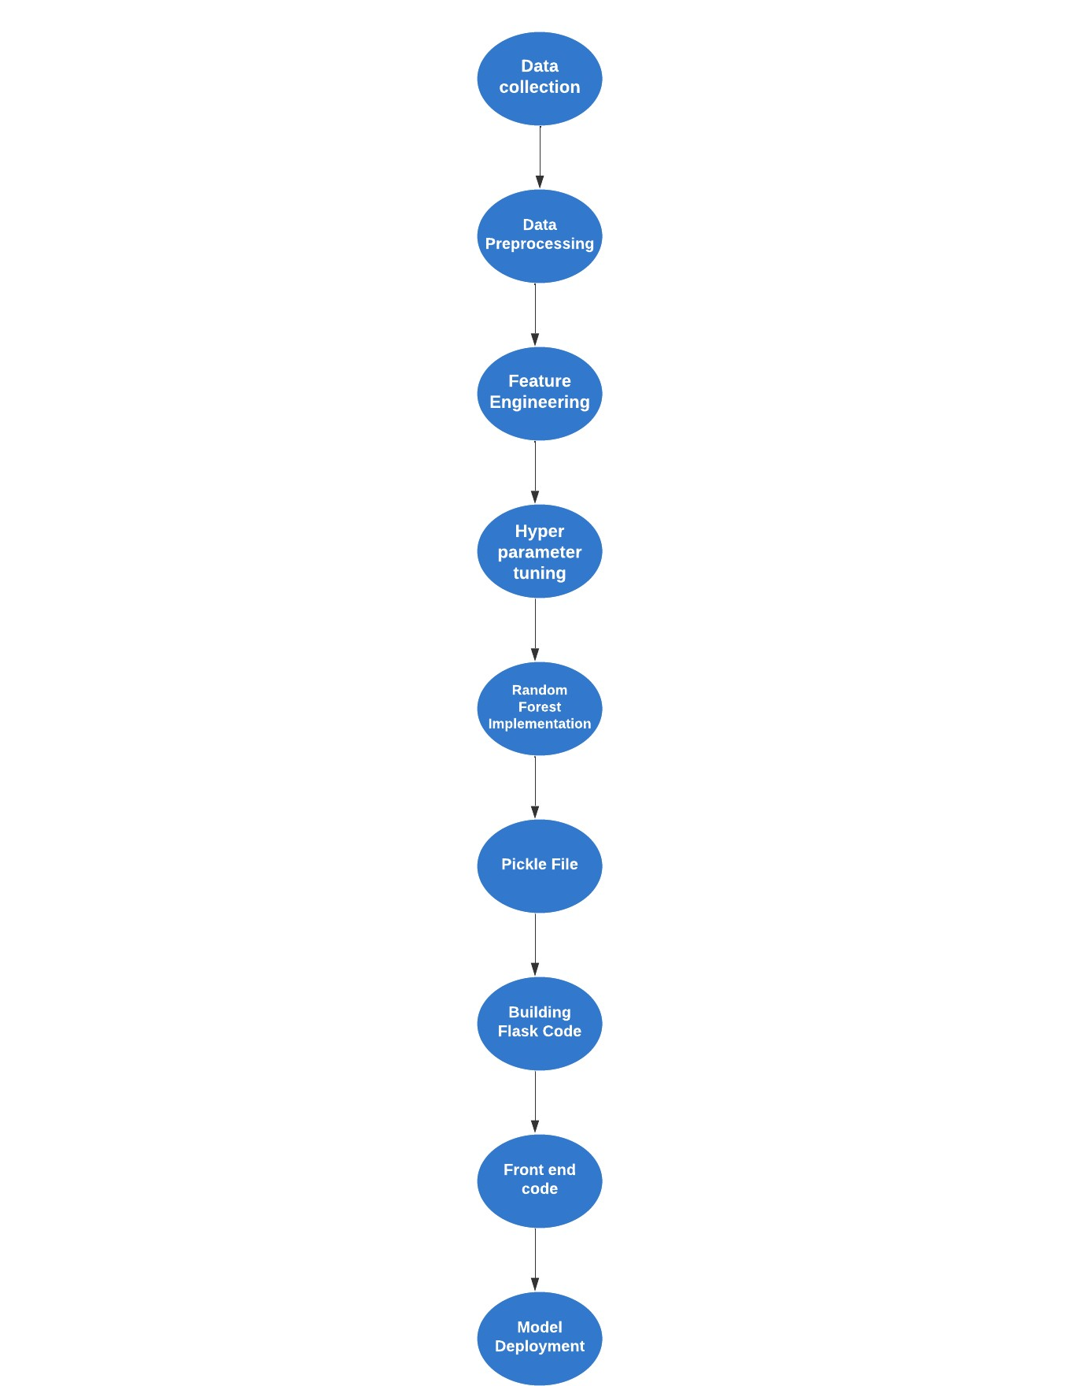

1. **RESULT**

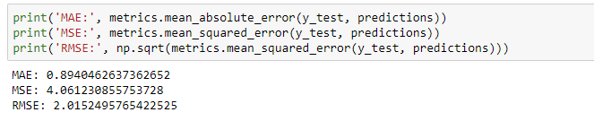

1. **ADVANTAGES**

• Random Forest algorithm can handle many input features.

• Provides robust predictions and handles non-linear relationships between features.

• Reduces overfitting by utilizing an ensemble of decision trees.

**DISADVANTAGES**

• Random Forest models can be computationally expensive and require sufficient resources.

• Interpretability of individual decision trees within the ensemble can be challenging.

1. **APPLICATIONS**

The car resale price prediction solution has various applications, including:

• Assisting car buyers in estimating the resale value of a used car before making a purchase.

• Helping sellers set a competitive and fair price for their cars.

• Supporting insurance companies in determining appropriate premiums based on a car's estimated resale value.

1. **CONCLUSION**

In conclusion, the project focused on developing a car resale price prediction system using the Random Forest algorithm. By leveraging historical data and analysing numerous factors, including make, model, age, mileage, and other features, the system can estimate the resale value of used cars accurately. The project successfully achieved its objectives by implementing and evaluating the Random Forest model. The results showed promising prediction accuracy and provided valuable insights into the factors influencing car resale prices.

**10. FUTURE SCOPE**

Although the project accomplished its goals, there are several potential enhancements and avenues for future work:

• Incorporating additional features: Explore the inclusion of more specific features related to the car's condition, maintenance history, geographical location, and market demand.

• Integration of real-time data: Develop mechanisms to continuously update the model with new data to improve prediction accuracy and adapt to changing market trends.

• Comparative analysis: Compare the performance of the Random Forest algorithm with other machine learning techniques to identify the most suitable model for car resale price prediction.

• User interface development: Build a user-friendly interface to make the system accessible to a broader audience, allowing users to input car details and obtain instant price predictions.

**11. BIBILOGRAPHY**

https://www.irjet.net/archives/V8/i5/IRJET-V8I5490.pdf#:~:text=Car%20resale%20value%20prediction%20is%20the%20system%20to,and%20accordingly%20the%20car%20resale%20value%20is%20predicted

https://link.springer.com/chapter/10.1007/978-981-16-8739-6_11